DEEP LEARNING FUNDUS IMAGE ANALYSIS FOR EARLY DETECTION OF DIABETIC RETINOPATHY

A Project report submitted inpartial fulfillment of the 7th semester in degree of

BACHELOR OF ENGINEERING
IN
Electronics and Communication Engineering
Submitted by

TeamID: PNT2022TMID24448

Diinesh kumar MP | 113319106020
Praveen P | 113319106059
Cegon Benadict JS | 113319106012
Sanjay kumar G | 113319106066



Department Of Electronics and Communication Engineering

ANNA UNIVERSITY CHENNAI - 600025

NOV-2022
Velammal Institute of Technology
(A Affiliated College of Anna University ,Chennai)

BONAFIDECERTIFICATE

CERTIFIED THAT THIS PROJECT REPORT “REAL TIME RIVER QUALITY MONITORING AND CONTROL SYSTEM” IS THE BONAFIDE RECORD WORKDONE BY.MR.MP.DIINESH KUMAR(113319106020)MR.P.PRAVEEN (113319106059), MR.JS.CEGON BENADICT(113319106012) ,
,MR.G.SANJAY KUMAR(113319106009) FOR “HX8001 PROFESSIONAL READINESS FOR INNOVATION,EMPLOYABILITY AND ENTREPRENEURSHIP ” IN VII SEMESTER OF B.E., DEGREE COURSE IN ELECTRONICS AND COMMUNICATION ENGINEERING BRANCH DURING THE ACADEMIC YEAR OF 2022-2023.

Staff-Incharge Evaluator
DR.M.Vijay

Head of the Department IndustryEvaluvator
Dr.Sridevi Dr. Bharadwaj

AKNOWLEDGEMENT

The satisfactions that accompany the successful completion of any task would be incomplete without mentioning the people who made it possible by their constant guidance and encouragement crowned our efforts with su ccess. We are grateful to our Chairman Shri. M.V.Muthuramalingam and our Director Shri. M.V.M.Sasikumar for facilitating us with this opportunity. Our sincere thanks to Advisor’s Shri. K.Razak and Shri.M. Vasu ,Principal Dr.N.Balaji
,Vice Principal Dr. S. Soundarajan for their support. Our respected Head of the Department of Electronics and Communication Engineering Dr.B. Sridevi, Project Evaluator Dr. B.Sridevi and Dr.Vijay and our Industrial mentor Sai Priya deserve a special note of thanks and gratitude for having extended their fullest cooperation and continuous suggestions to make this project successful. We also thank all the faculty members of Electronics and Communication Engineering department for their help during the course of this project. We also like to express our gratefulness to our beloved parents and our family members who have always provided backup with their unending moral support and of course momentary help too which we believe are the driving forces for the completion of the project.
Diinesh Kumar MP (Lead)
Praveen P
Sanjay kumar N
Cegon Benadict J

INDEX

- INTRODUCTION

  - Project Overview

  - Purpose 2.LITERATURE SURVEY
  - Existing problem

  - References

  - Problem Statement Definition 3.IDEATION & PROPOSED SOLUTION
  - Empathy Map Canvas

  - Ideation & Brainstorming

  - Proposed Solution

  - Problem Solution fit 4.REQUIREMENT ANALYSIS
  - Functional requirement

  - Non-Functional requirements 5.PROJECT DESIGN
  - Data Flow Diagrams

  - Solution & Technical Architecture

  - User Stories

- PROJECT PLANNING & SCHEDULING

  - Sprint Planning & Estimation

  - Sprint Delivery Schedule

  - Reports from JIRA 7.CODING & SOLUTIONING
  - Feature 1

  - Feature 2 8.TESTING
  - Test Cases

  - User Acceptance Testing 9.RESULTS
9.1 Performance Metrics 10.ADVANTAGES & DISADVANTAGES 11.CONCLUSION
- FUTURE SCOPE

- APPENDIX

  - Source Code

  - GitHub & Project Demo Link

INTRODUCTION

Project Overview:

River Water quality monitoring System

River water which is used as drinking water is a very precious commodity for all human beings.The system consists of several sensors which are used for measuring physical and chemical parameters of water. The parameters such as temperature, pH, and dissolved oxygen of the water can be measured. Using this system a person can detect pollutants from a water body from anywhere in the world.Current water quality monitoring system is a manual system with a monotonous process and is very time-consuming This paper proposes a sensor- based water quality monitoring system. The main components of Wireless Sensor Network (WSN) include a micro-controller for processing the system, communication system for inter and intra node communication and several sensors Real-time data access can be done by using remote monitoring and Internet of Things (IoT) technology Data collected at the IBM cloud Server and verify them to trigger the actions to be performed.

Purpose:

Water quality refers to chemical, physical biological and radio logical characteristics of water. It is a measure of the condition of water relative to the necessities of one or more bio-tic species and or to any human need or purposes .Water quality monitoring is defined as a sampling and analysis of the water in lake, stream, ocean and river and conditions of the water body. Smart water quality monitoring is a process of real-time monitoring and the analysis of water to identify changes in parameters based on the physical, chemical and biological characteristics. Monitoring water quality is clearly important: in our seas, rivers, on the surface and in our ports, for both companies and the public. It enables us to assess how they are changing, analyze trends and to inform plans and strategies that improve water quality and ensures that water meets its designated use.There are several indicators determining water quality. These include dissolved oxygen, turbidity, bio indicators, nitrates, pH scale and water temperature.Monitoring water quality helps to identify specific pollutants, a certain chemical, and the source of the pollution.There are many sources of water pollution: wastewater from sewage seeping into the water supply; agricultural practices (e.g., the use of pesticides and fertilizer); oil pollution, river and marine dumping, port, shipping and industrial activity. Monitoring water quality and a water quality assessment regularly provides a source of data identify immediate issues – and their source.

    - Identifying trends, short and long-term, in water quality.

    - Data collected over a period of time will show trends, for example identifying increasing concentrations of nitrogen pollution in a river or an inland waterway. The total data will then help to identify key water quality parameters.
    - Environmental planning methods: water pollution prevention and management.

    - Collecting, interpreting and using data is essential for the development of a sound and effective water quality strategy. The absence of real-time data will however hamper the development of strategies and limit the impact on pollution control. Using digital systems and programs for data collection and management is a solution to this challenge.
    - Monitoring water quality is a global issue and concern: on land and at sea. Within the European Union, the European Green Deal sets out goals for restoring biological biodiversity and reducing water pollution, as well as publishing various directives to ensure standards of water quality. Individual nation states, for example France, have also clear regulatory frameworks requiring the effective monitoring of water quality. In the United States, the Environmental Protection Agency (EPA) enforces regulations to address water pollution in each state. Across the world, countries increasingly understand the importance of effective water quality monitoring parameters and methods.

LITERATURE SURVEY

Project title: Real time river water quality monitoring and control system
Survey 1:
River water quality monitoring is the process of measuring the water quality parameters, such as temperature, pH, turbidity, dissolved oxygen levels, variety of ions present, and so on. The main objective of monitoring water quality is to ensure these parameters are within a suitable range. The traditional method of water monitoring was done physically, using only chemicals. A water quality monitoring application involves using different IoT-based smart sensors that keep track of the parameters in real-time. The hardware components
used for this project are pH sensor, Ultrasonic sensor, Turbidity sensor, Thermometer sensor, RF module
Advantages:Pure water in healthcare facilities,A healthy water supply made possible. Disadvantages:The waters in many supply systems have to be allocated based on past availability or existing consumer demand. The practice does not necessarily mean the allocation is proper. In fact, some supply systems can get overly crowded.

Survey 2:
A statistical model based on Internet of Things (IoT) for water quality analysis using different water quality parameters such as pH, conductivity, dissolved oxygen, temperature, biochemical oxygen demand, total dissolved solids and conductivity. These parameters are very important to assess the water quality of the river. The traditional manual technique
that is under use is a very slow process. It requires staff to collect the water samples from the site and take them to the laboratory and then perform the analysis on various water parameters which is costly and time-consuming process.
Advantages: Aquatic life preservation practical, Achieve sustainability through LEED and/or
WELL certifications.
Disadvantages: There are no specific management plans or sanctions on water extractions in many areas, such as pumping groundwater or rivers. These have caused less water to be

soluble and even led to the mining of that resource in some respects. This hampers the water levels and increases the risk of contaminated water.

Survey 3:
This research paper focuses on Wireless Sensor Network for River Water Quality Monitoring in India.This paper introduces a river water quality monitoring system based on wireless sensor network which helps in continuous and remote monitoring of the water quality data in India. The wireless sensor node in the system is designed for monitoring the pH of water, which is one of the main parameters that affect the quality of water.
Advantages:
Wireless sensor Network which aids in River Water Quality Monitoring. This paper also proposes a novel technique for the design of a water quality sensor node which can be used for monitoring the pH of water.
Disadvantages:
This paper focuses only on the pH of river water here the other parameters such as turbidigity,conductivity and temperature are not considered.

Survey 4:
This research paper focuses on Detection on water pollution and water management using smart sensors iotTo ensure the safe supply of drinking water the quality should be monitored in real time for that purpose new approach IOT (Internet of Things) based water quality monitoring has been proposed.This system consists some sensors. Which measure the water quality parameter such as pH, turbidity, conductivity, dissolved oxygen, temperature. The measured values from the sensors are processed by microcontroller and these processed values are transmitted remotely to the core controller that is raspberry pi using Zigbee protocol.
Advantages:
Based on a study of existing water quality monitoring system and scenario of water we can say that proposed system is more suitable to monitor water quality parameters in real time.

Survey 5:

Author: J.Navarajan

Detection on water pollution and water management using smart sensors iot To ensure the safe supply of drinking water the quality should be monitored in real time for that purpose new approach IOT (Internet of Things) based water quality monitoring has been proposed.This system consists some sensors. Which measure the water quality parameter such as pH, turbidity, conductivity, dissolved oxygen, temperature. The measured values from the sensors are processed by microcontroller and these processed values are transmitted remotely to the core controller that is raspberry pi using Zigbee protocol. Based on a study of existing water quality monitoring system and scenario of water we can say that proposed system is more suitable to monitor water quality parameters in real time. Based on a study of existing water quality monitoring system and scenario of water we can say that proposed system is more suitable to monitor water quality parameters in real time.

Survey 6:

Author: NatasaMarkovic

Sensor Web for River Water Pollution Monitoring and Alert SystemSensor Web has provided infrastructure for collecting and processing data from distributed and heterogeneous sensors. This set of technologies has found various implementations, especially in the area of environmental monitoring. The Sensor Web architecture for crisis management, described in this paper, provides active monitoring of measuring parameters and timely responses in cases of environmental disasters. The River Water Management and Alert System built on this architecture enable access,
control and management of river water pollution

Advantages and Disadvantages :

Existing system has a mechanisms which are semi-automated or manually controlled devices which are to be handled by a person responsible for monitoring the water quality. There is need to have human intervention in taking various reading of the water parameters. The instruments or tools are used either by putting/inserting a water sensing part into water and seeing the result on small display device or by directly inserting a portable device in water and watching the output on the display. Central Water Commission (CWC) monitors water quality, by collecting samples from representative locations within the processing and distribution system. These samples are analyzed at the well-equipped laboratories. At these laboratories, samples of raw water, filter water and treated water are taken for analysis, these analysis can be performed by human intervention which for specific period only. The disadvantage of this system is, water is not monitoring seamlessly, and it always needs a human intervention.

Survey 7:
This research paper focuses on Sensor Web for River Water Pollution Monitoring and Alert SystemSensor Web has provided infrastructure for collecting and processing data from distributed and heterogeneous sensors. This set of technologies has found various implementations, especially in the area of environmental monitoring. The Sensor Web architecture for crisis management, described in this paper, provides active monitoring of measuring parameters and timely responses in cases of environmental disasters.

Advantages:

The River Water Management and Alert System built on this architecture enable access, control and management of river water pollution.

Survey 8:

This research paper focuses on Wireless Sensor Network for River Water Quality Monitoring in India This paper introduces a river water quality monitoring system based on wireless sensor network which helps in continuous and remote monitoring of the water quality data in India. The wireless sensor node in the system is designed for monitoring the pH of water, which is one of the main parameters that affect the quality of water. Wireless sensor Network which aids in River Water Quality Monitoring.

Advantages:

This paper proposes a novel technique for the design of a water quality sensor node which can be used for monitoring the pH of wate

References:

    - K.S. Adu-Manu, C. Tapparello, W. Heinzelman, F.A. Katsriku, J.-D. Abdulai

Water quality monitoring using wireless sensor networks: Current trends and future research directions ACM Transactions on Sensor Networks (TOSN) (2017).
    - S. Thombre, R.U. Islam, K. Andersson, M.S. Hossain

IP based Wireless Sensor Networks : performance Analysis using Simulations and Experiments.Journal of Wireless Mobile Networks, Ubiquitous Computing, and Dependable Applications, 7 (2016).
    - Rushikesh Kshirsagar, R.Mudhalwadkar, Saish Kalaskar

Design and Development of IoT Based Water Quality Measurement System. The idea about low-cost IOT based portable approach for water quality measurements system. Because of its low-cost approach, everyone can afford to use it to determine quality of water(2019).

The real time monitoring of water quality in IoT environment. The parameters such as temperature, PH, turbidity, conductivity, dissolved oxygen of the water can be measured. The measured values from the sensors can be processed by the core controller. The raspberry PI B+ model can be used as a core controller (2015).
    - M.Chitra, D. Sadhihskumar, R. Aravindh, M. Murali, R. Vaittilingame

IoT based Water Flood Detection and Early Warning System.The collected information (data) from the water level sensor and temperature and humidity sensor passed to Thingview Android application in order to find the flow graph level of the water level in the river and temperature, humidity values and sends SMS to the registered contact mobile numbers (2020).
    - Dr.Geetha

IoT based real time water quality monitoring system using smart sensor

WQM is a cost effective and efficient system designed to monitor drinking water quality with the help of IOT(2020).

Problem Statement:

Customer Problem Statement Template:

Create a problem statement to understand your customer's point of view. The Customer Problem Statement template helps you focus on what matters to create experiences people will love.

A well-articulated customer problem statement allows you and your team to find the ideal solution for the challenges your customers face. Throughout the process, you’ll also be able to empathize with your customers, which helps you better understand how they perceive your product or service.

Problem  Statement (PS) | I am  (Customer) | I’m trying to | But | Because | Which makes me feel
PS-1 | A farmer | Check the water quality. | Procedure to find the quality will be more  And take more time. | Generally specific researcher only handles this. | Helpless most of the time.
PS-2 | A drinking water supplier | Check the level of chlorine in water. | I need to depend on any third party water  Researcher. | My lack of knowledge on water quality. | More dependence and expenditure on water search.
PS-3 | Industrialist | Check type of water | I need to depend on any third party water  Researcher. | General specific research only handles this. | That it is an additional expense
PS-4 | Fishermen | Find if the water is suitable for aquaculture | It is difficult to obtain the results | My lack of knowledge on water quality. | That it is costly

IDEATION & PROPOSED SOLUTION

  - Empathy Map Canvas:

An empathy map is a simple, easy-to-digest visual that captures knowledge about a user’s behaviours and attitudes. It is a useful tool to helps teams better understand their users.Creating an effective solution requires understanding the true problem and the person who is experiencing it. The exercise of creating the map helps participants consider things from the user’s perspective along with his or her goals and challenges.

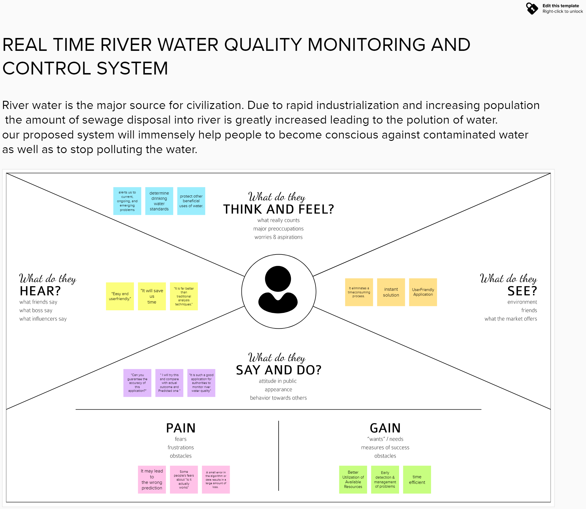

Ideation & Brainstorming:

Brainstorming provides a free and open environment that encourages everyone within a team to participate in the creative thinking process that leads to problem solving. Prioritizing volume over value, out-of-the-box ideas are welcome and built upon, and all participants are encouraged to collaborate, helping each other develop a rich amount of creative solutions.
Use this template in your own brainstorming sessions so your team can unleash their imagination and start shaping concepts even if you're not sitting in the same room.
Reference:https://app.mural.co/invitation/mural/ibmproject1215/1666848258091?sender=uf9 3f4fc8b3ed9d16cc620908&key=d4906cd4-138e-40f9-a546-ea061cc6c665

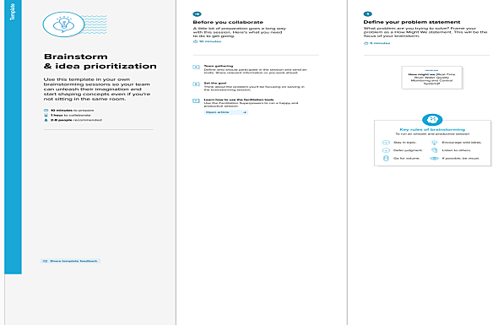
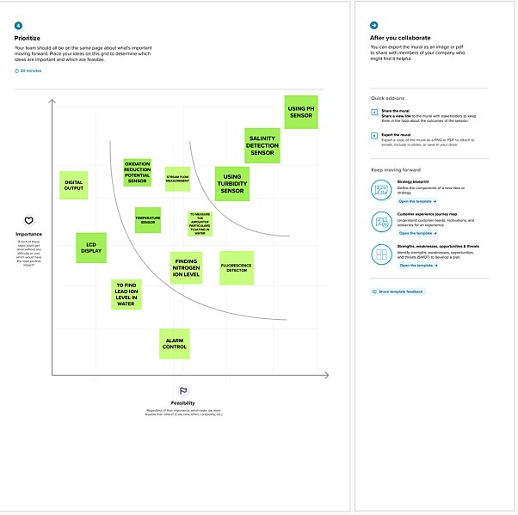

Proposed Solution:

S.No. | Parameter | Description
1. | Problem Statement (Problem to be solved) | Due to population growth,urbanization,and climatic change,competition for water resources is expected to increase,with a particular impact on agriculture,river water.
2. | Idea / Solution description | To monitor the water supply we implement IoT (Internet of Things)setup, for river water quality monitoring systems periodically checks,dust particles,temperature and PH level by sensors and notifies for public when the water quality vaires.
3. | Novelty / Uniqueness | We use water detection sensor has unique advantage.It consumes less time to monitor than a manual method for checking polluted levels,and notifies immediately to reduce  affected rate of pollution in water.
4. | Social Impact / Customer Satisfaction | People who are living in rural areas near to the river will be very satisfied with our idea.It will be useful to monitor water pollution in specific area.So this system prevent people from water pollution.It will be used for farming purpose to check quality water,temperature and PH level.Our Impact of this project is also create a social satisfaction for farmers too.

5. | Business Model (Revenue Model) | It costs low compared to other model.Our real time quality monitoring model has sensors easily helps to monitor and predict the affected water scale easily in farming, drinking water,aquaculture,and other industries.It notifies by sending directly to the corporation and they can further notify the people to aware immediately.Quick actions can be taken.With the help of efficient use of mobile network,IoT and continuous monitoring it will be revolutionized model.
6. | Scalability of the Solution | Checking the river water quality for providing clean drinking water for the people, farming, promoting aquaculture, and other industries. It is the best replacement for checking water quality in laboratories and it is user-friendly.If we add more advanced sensors in future it can be used to monitor multiple levels in water.It will show continuous real time values in maintaining the quality of water.

PROBLEM SOLUTION:

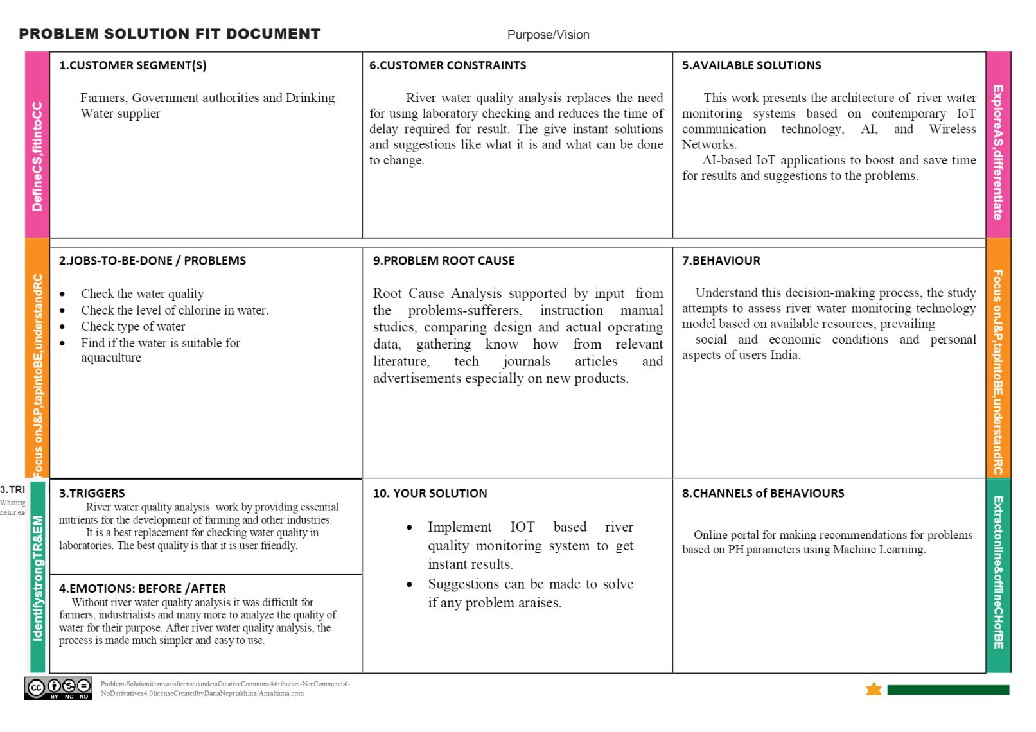
4 REQUIREMENT ANALYSIS

  - Functional Requirements:

Following are the functional requirements of the proposed solution.

FR No. | Functional Requirement  (Epic) | Sub Requirement (Story / Sub-Task)
FR-1 | User Registration | Registration through Form Registration through Gmail  Registration through LinkedIN
FR-2 | User Confirmation | Confirmation via Email  Confirmation via OTP
FR-3 | Ultrasonic generator | Periodically the waves are generated to destroy algae in the range of  25%,50%,100%
FR-4 | Ph level detection | To observe the water quality, Ph sensor is used and the  signals are conveyed to the Arduino.
FR-5 | Turbidity detection | Turbidity sensor measures the purity of element or marshy utter in the water and the signals are delivered  to Arduino

Non-functional Requirements:

Following are the non-functional requirements of the proposed solution.

FR No. | Non-Functional Requirement | Description
NFR-1 | Usability | Monitors the ﬂow and quality of  ground water, and investigates surface- and ground-water  interactions.
NFR-2 | Security | The data and information are secured  in the application by using the application ﬁrewall.
NFR-3 | Reliability | The Real time sensor output values  with future predicted data storage with output eﬃciency of 98%. It also  gives certainty for aquaculture safety.
NFR-4 | Performance | The performance of system has higher  eﬃciency and environmental friendly.
NFR-5 | Availability | It is available in the form of mobile UI  24 x 7 monitoring system.
NFR-6 | Scalability | The system has high scalability. Able  to be changed in size or scale to give the best output.
NFR-7 | Stability | The ability of the system to bring itself  back to its stable conﬁguration. The stability is high.
NFR-8 | Eﬃciency | The monitoring system is highly  Eﬃcient, high mobility with consumption of power.

5 PROJECT DESIGN

  - Data Flow Diagrams:

A Data Flow Diagram (DFD) is a traditional visual representation of the information flows within a system. A neat and clear DFD can depict the right amount of the system requirement graphically. It shows how data enters and leaves the system, what changes the information, and where data is stored.

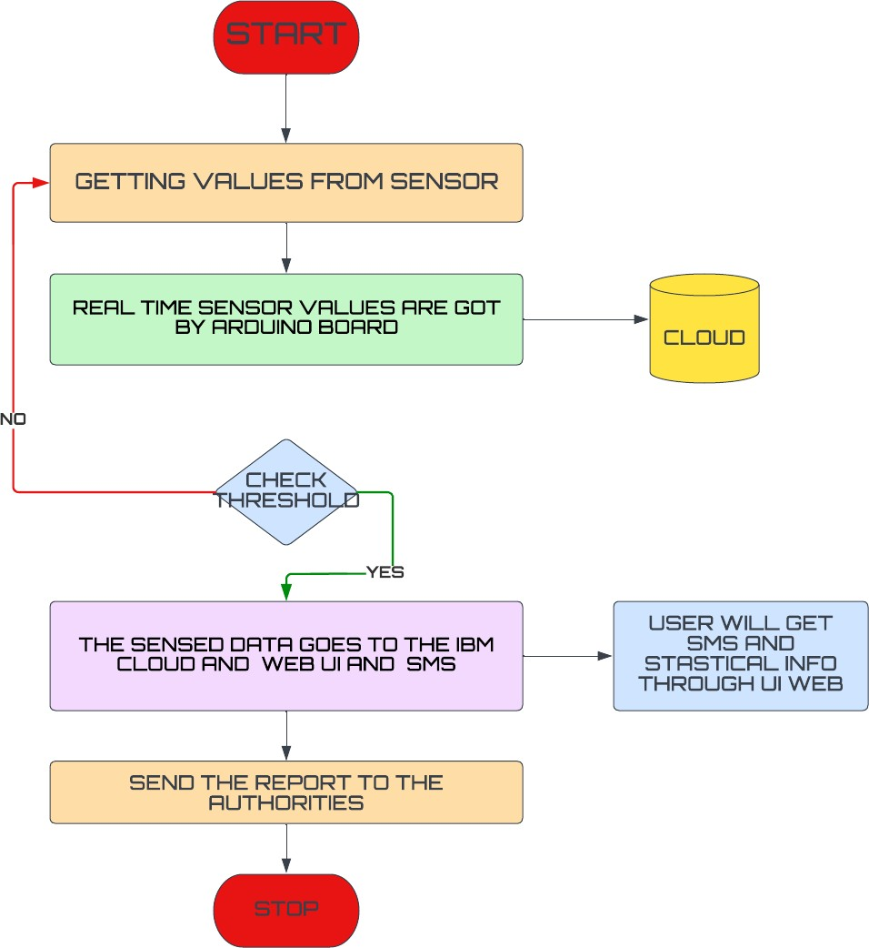

SOLUTION AND TECHNICAL ARCHITECTURE

Summary

This code pattern explains how to build an IOT based river water monitoring and controlling system with some predefined values.

Flow
    - Feed the data received from the Sensor unit which are placed in the river sides.
    - The collected data will be displayed in the Web page to the user.
    - Then the collected data is sent to the data base, where the collected data and the predefined data are checked and
monitored.
    - If any data exceed the predefined data then the control signal will send to the Admin.
    - The collected data will be stored in the IBM cloud storage. Later the data will be controlled by the admin via Web UI.

Components & Technologies:

S.No | Component | Description | Technology
1. | Sensor Data | The data is collected form the various sensor placed  in the river sides. | ESP32Wifi module Raspberry Pie.
2. | Database for Storage | The data/info need to be stored for accessing it in  future | MySQL-Oracle
3. | File Storage | File storage requirements | IBM Block Storage or Other Storage Service or Local Filesystem
4. | Cloud Database | Database Service on  Cloud | IBM cloud
5. | Data Storage | File storage requirements | IBM Block Storage

Application Characteristics:

S.No | Characteristics | Description | Technology
1. | PH level Monitoring | The PH level of river water can be monitoredvia placing sensors in  rivers. | PH-sensor
2. | Air Quality Monitoring | The clarity and purity ofriver water can be monitored | Surface Mount Sensor
3. | Temperature Monitoring | The temperature of river water can be monitored | Temperature sensor
4. | Water Treatment | can be used as both a safety device in the water purification process as carbon dioxide, methane, and carbon monoxide are some of the key gases produced during the  treatment process | NDIR gas sensors
4. | Soil Condition Monitoring | Soil condition monitoring sensors allow farmers to collect data about rainfall, temperature, and other metrics over time to track trends and predict irrigation needs. | Acoustic sensor

User Stories
Use the below template to list all the user stories for the product.

User Type | Functional Requireme  nt (Epic) | User Story  Number | User Story / Task | Acceptance criteria | Priority | Release
Customer (Mobile user) | Registration | USN-1 | As a user, I can register for the application by entering my email, password, and confirming my password. | I can access my account  /dashboard | High | Sprint-1
 |  | USN-2 | As a user, I will receive confirmation email once I have registered for the application | I can receive confirmation email & click confirm | High | Sprint-1
 |  | USN-3 | As a user, I can register for the application through Google | I can register & access the dashboard with Google Login | Low | Sprint-2
 |  | USN-4 | As a user, I can register for the application through G mail | I can access through Gmail | Medium | Sprint-1
 | Login | USN-5 | As a user, I can log into the application by entering email & password | Login Details are received to me. | High | Sprint-1
 | Interface | USN-6 | As a user, I can log into the application by  entering email & password. | Easy Access application | High | Sprint-1
Customer (Web user) | Dashboard | WUSN-7 | As a web User, I can get all information (data)(Temp etc..) | I can easily Understand how to use it. | High | Sprint-1
Customer Care Executive | View Perspective | CCE | As a Customer care, I can view the data in graph plots | Easy Understanding of Graphs | High | Sprint-1
Administrator | Risk factor | ADMIN- 1 | As a Admin, Update must be done at each step and take care of any errors | Heavy Monitoing is Required. | High | Sprint-2

PROJECT PLANNING AND SCHEDULING

  - SPRINT PLANNING & SCHEDULING:

TITLE | DESCRIPTION | DATE
Literature Survey & Information Gathering | Literature survey on  the selected project is done by gathering information about related details on technical papers and  web browsing. | 06 OCTOBER  2022
Empathy Map | Prepared Empathy Map  Canvas to combine thoughts and pains, gains of the project with all team members . | 08 OCTOBER  2022
Ideation | Brainstorming session is conducted with all team members to list out all the ideas and prioritise the top 3 ideas. | 09 OCTOBER  2022
Proposed Solution | Prepared the proposed solution document, which includes the novelty, feasibility of idea, business model, social impact, scalability of solution, etc. | 28 OCTOBER  2022
Problem Solution Fit | Prepared problem - solution ﬁt document. | 30 OCTOBER  2022

  - SPRINT DELIVERY SCHEDULE

Product Backlog, Sprint Schedule, and Estimation

Use the below template to create product backlog and sprint schedule

Sprint | Functional Requirement (Epic) | User story  Numb err | User Story / Task | Story Points | Priority | Team  Members
Sprint-1 | Registration | USN-1 | As a user, I can register for the application by  entering my email, password, and confirming  My password. | 2 | High | MP DIINESH KUMAR, PRAVEEN P,  SANJAY KUMAR G, CEGON BENADICT JS
Sprint-1 | Registration via Facebook | USN-3 | As a user, I can register for the application  through Facebook | 2 | Low
Sprint-1 | Registration via Mail ID | USN-4 | As a user, I can register for the application through Gmail | 2 | Medium
Sprint-2 | Confirmation | USN-2 | As a user, I will receive confirmation email onceI  have registered for the application | 1 | High
Sprint-2 | Login | USN-5 | As a user, I can log into the application by entering email & password | 1 | High
 | IBM Cloud service  Access | USN-5 | Get access to IBM cloud services. | 2 | High
Sprint-3 | Create the IBM Watson  IoT and deviceSettings | USN-6 | To create the IBM Watson IoT Platform and integrate  the microcontroller with it, to send the sensed data on  Cloud | 2 | High | G SANJAY,  PRAVEEN P, DIINESH KUMAR MP
Sprint-3 | Create a node red service | USN-7 | To create a node red service to integrate the IBM  Watson along with the Web UI | 2 | medium | PRAVEEN, SANJAY CEGON
Sprint-3 | Create a Web UI | USN-8 | To create a Web UI, to access the data from the cloud  And display all parameters. | 2 | Medium | DIINESH  KUMAR MP

Project Tracker, Velocity & Burndown Charts

Sprint | Total Story Points | Durati on | Sprint Start Date | Sprint End Date (Planned) | Story Points Completed (ason Planned  End Date) | Sprint Release Date (Actual)
Sprint-1 | 20 | 6 Days | 24 Oct 2022 | 29 Oct 2022 | 20 | 27 Oct 2022
Sprint-2 | 20 | 6 Days | 28 Oct 2022 | 04 Nov 2022 | 30 | 30 Oct 2022
Sprint-3 | 20 | 6 Days | 03 Nov  2022 | 10 Nov 2022 | 49 | 04 Nov 2022
Sprint-4 | 20 | 6 Days | 08 Nov  2022 | 15 Nov 2022 | 50 | 09 Nov 2022

Velocity:

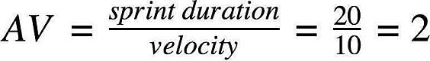

Burndown Chart:

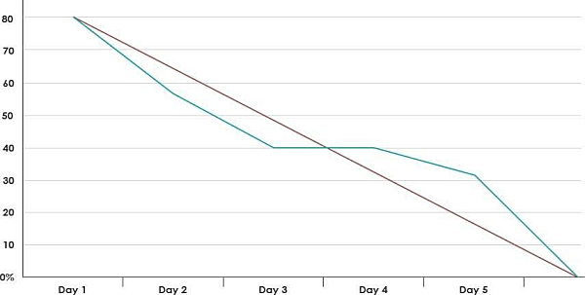

REPORT FROM JIRA

REFERENCE LINK (JIRA SOFTWARE):
https://ibmprojectrealtimemonitoring.atlassian.net/jira/core/projects/RE/board

TIMELINE CREATED USING JIRA SOFTWARE
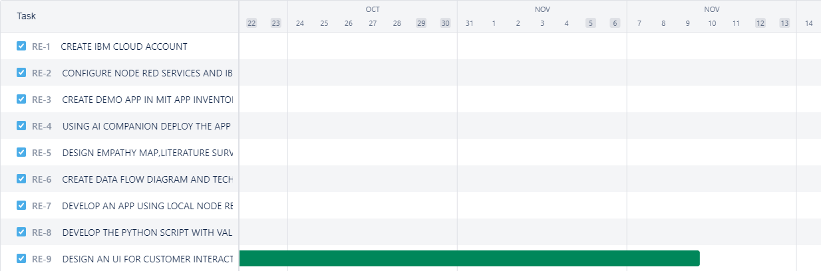
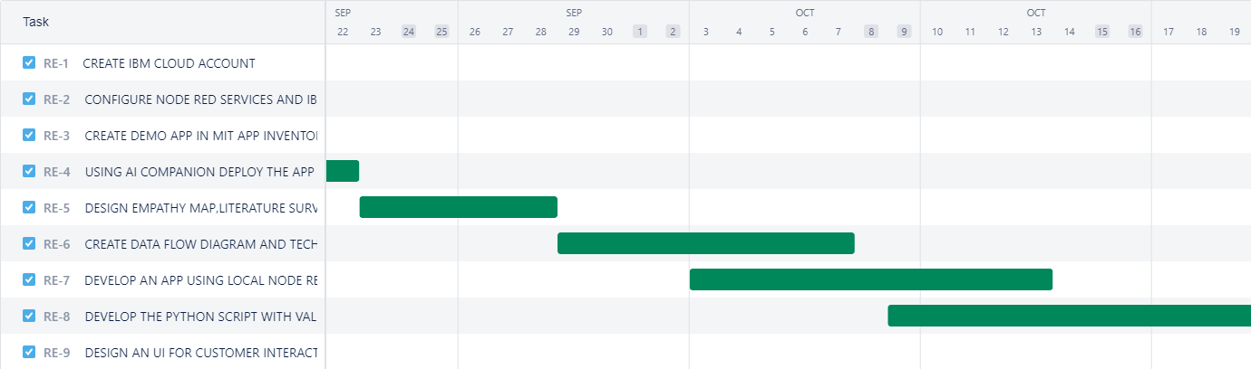
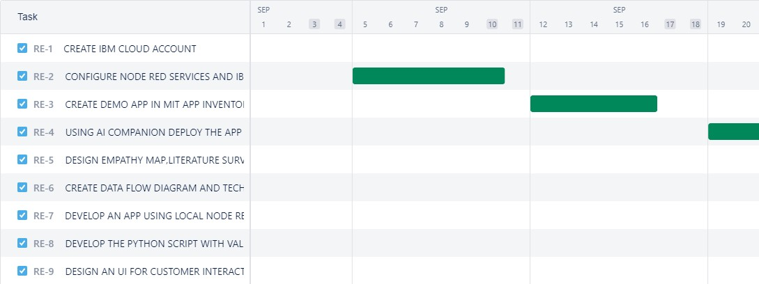

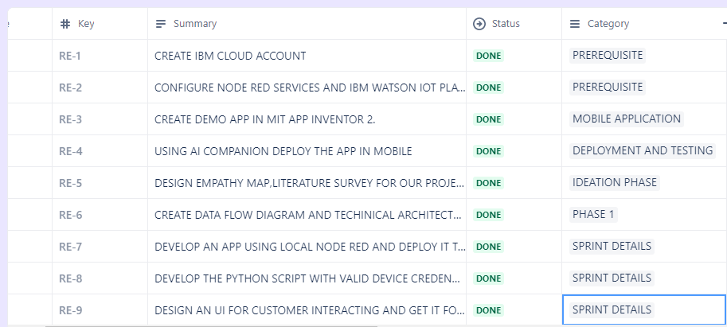
LISTS IN JIRA:

ISSUES :
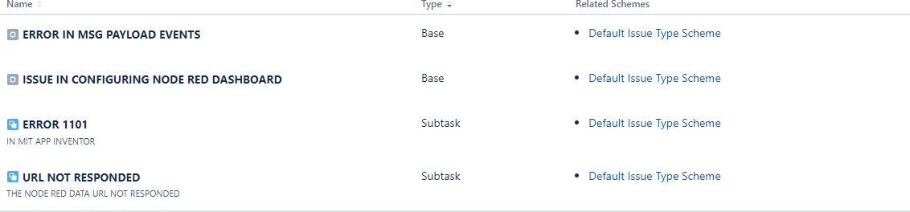

CODING AND SOLUTIONING

7.1 NODE RED SERVICE ASSOCIATED WITH IBM CLOUD:

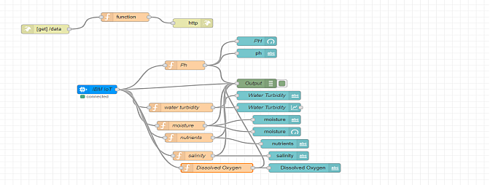

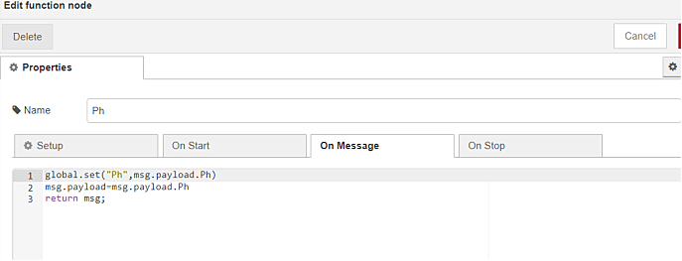

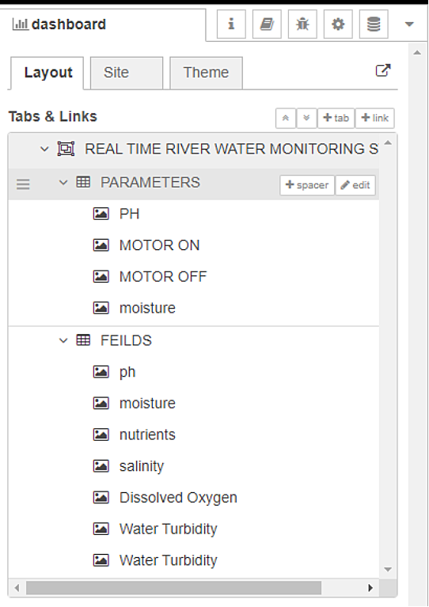
Node red Dashboard:

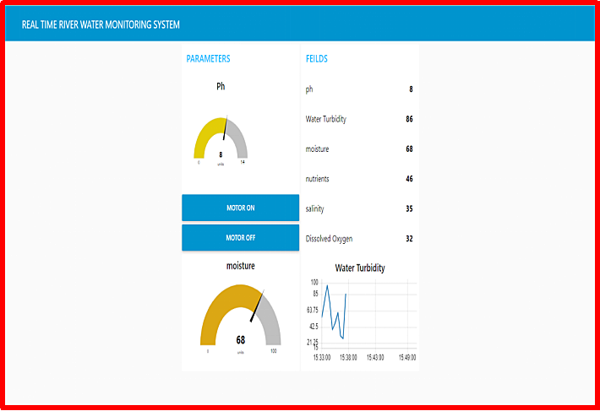

TESTING

  - Test Case Analysis

This report shows the number of test cases that have passed, failed, and untested

Section | Total Cases | Not Tested | Fail | Pass
Print Engine | 15 | 0 | 0 | 15
Client Application | 45 | 0 | 0 | 45
Security | 1 | 0 | 0 | 1
Outsource Shipping | 2 | 0 | 0 | 2
Exception Reporting | 10 | 0 | 0 | 10
Final Report Output | 4 | 0 | 0 | 4
Version Control | 3 | 0 | 0 | 3

USER ACCEPTANCE TESTING:

Purpose of Document
The purpose of this document is to briefly explain the test coverage and open issues of the REAL TIME RIVER WATER QUALITY MONITORING AND CONTROL SYSTEMS
project at the time of the release to User Acceptance Testing (UAT).

Defect Analysis
This report shows the number of resolved or closed bugs at each severity level, and how they were resolved

Resolution | Severity 1 | Severity 2 | Severity 3 | Severity 4 | Subtotal
By Design | 9 | 5 | 4 | 3 | 21
Duplicate | 2 | 0 | 2 | 0 | 4
External | 3 | 4 | 1 | 2 | 10
Fixed | 10 | 1 | 5 | 17 | 33
Not  Reproduced | 0 | 0 | 1 | 0 | 1
Skipped | 0 | 0 | 1 | 2 | 3
Won't Fix | 0 | 3 | 3 | 1 | 7
Totals | 24 | 13 | 17 | 25 | 79

RESULT

  - PERFROMANCE METRICS:

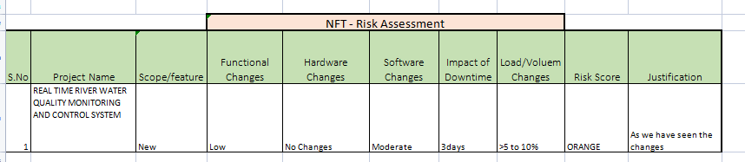

PERFORMANCE TABLE

PARAMETER | PERFORMANCE | DESCRIPTION
ADMIN TESTING | 95%-100% | THE TESTING DONE BEFORE IT IS  DEPLOYED AS AN APP
CUSTOMER SATISFACTION | 75-85% | THE CUSTOMER NEED TO BE SATISFIED WITH THE MOBILE  APPLICATION
USER INTERFACE | 65-85% | THE APP CAN USED BY ANYONE.(EASE OF  ACCESS)
SEVER RESPONSE | 50-75% | url - response
DATA VALIDATION WITH NO. OF TEST  CASE | 60-80%  (15-30  TESTCASE) | VALID DATA FROM THE APP
ERROR | 3-5% | REAL-TIME DELAY  MAY OCCUR

ADVANTAGES AND DISADVANTAGES

ADVANTAGES:

    - The prototype developed for water quality maintenance is very beneficial for safeguarding public health and also adds to the clean environment.
    - The automation of this water monitoring, cleaning and control process removes the need of manual labor and thus saves time and money.
    - The automation of the system makes the control and monitoring process more efficient and effective. Real time monitoring on mobile phone which is possible through the interface of plc with Arduino and Bluetooth module allows remote controlling of the system.

DISADVANTAGES:

    - It is difficult to collect the water samples from all the area of the water body.
    - The cost of analysis is very high.
    - The lab testing and analysis takes some time and hence the lab results does not reflect real time water quality measurement due to delay in measurement.
    - The process is time consuming due to slow process of manual data collection from different locations of the water body.
    - The method is prone to human errors of various forms.

CONCLUSION

Thus our project is used to Monitoring of Turbidity, PH & Temperature of Water makes use of water detection sensor with unique advantage and existing GSM network. The system can monitor water quality automatically, and it is low in cost and does not require people on duty. So the water quality testing is likely to be more economical, convenient and fast. The system has good flexibility. Only by replacing the corresponding sensors and changing the relevant software programs, this system can be used to monitor other water quality parameters.
The operation is simple. The system can be expanded to monitor hydrologic, air pollution, industrial and agricultural production and so on. It has widespread application and extension value.By keeping the embedded devices in the environment for monitoring enables self protection (i.e., smart environment) to the environment. To implement this need to deploy the sensor devices in the environment for collecting the data and analysis. By deploying sensor devices in the environment, we can bring the environment into real life i.e. it can interact with other objects through the network.
Then the collected data and analysis results will be available to the end user through the Wi-Fi.

FUTURE SCOPE

We use water detection sensor has unique advantage.It consumes less time to monitor than a manual method for checking polluted levels,and notifies immediately to reduce affected rate of pollution in water.People who are living in rural areas near to the river will be very satisfied with our idea.It will be useful to monitor water pollution in specific area.So this system prevent people from water pollution.It will be used for farming purpose to check quality water,temperature and PH level.Our Impact of this project is also create a social satisfaction for farmers too.The scalabilty of this project gives the addition of more different type of sensors.By interfacing the relay we can control the supply of water. We can also implement as a revenue model.This system could also be implemented in various industrial processes. The system can be modified according to the needs of the user and can be implemented along with lab view to monitor data on computers.

13.APPENDIX

  - SOURCE CODE:

PYTHON CODE TO PUBLISH DATA

#program to publish data in ibm watson iot platform import time
import sys
import ibmiotf.application import ibmiotf.device import random
#Provide your IBM Watson Device Credentials

#Org_ID
organization = "84708c" #Device Type deviceType = "abcd" #device ID
deviceId = "12345" #Method of Authentication authMethod = "token" #Auth-token
authToken = "12345678"

# exception handling method #try block
try:

deviceOptions = {"org": organization, "type": deviceType, "id": deviceId, "auth-method":authMethod, "auth-token":authToken}
deviceCli= ibmiotf.device.Client (deviceOptions)

#to handle the errors except Exception as e:
print ("Caught evention connecting device: %s" % str(e)) sys.exit()
#device connection deviceCli.connect()
#while Loop for getting the values while True:
Ph=random.randint (6,8)
WaterTurbidity=random.randint (15,100)
salinity=random.randint (500,1000)
DissolvedOxygen=random.randint (60,130)
conductivity=random.randint (100,1200) data = {'Ph' : Ph,
'WaterTurbidity':WaterTurbidity,'salinity':salinity,'DissolvedOxygen': DissolvedOxygen,'conductivity':conductivity}
#define myonpublishcallback function def myonPublishCallback():
print ("Published Ph = %s" % Ph, "WaterTurbidity = %s %%" % WaterTurbidity,"salinity = %s" % salinity,"DissolvedO2 = %s" % DissolvedOxygen,"conductivity = %s" % conductivity)
if(Ph<7.4 and salinity < 600 and DissolvedOxygen < 80 and conductivity < 200):
if(Ph>7.4 and salinity > 900 and DissolvedOxygen > 120 and conductivity > 1100):
print("UNSAFE, THE VALUES OF PARAMETERS ARE NOT IN THE RANGE")
else:
print("Quality of River water is measured and its correct")

success = deviceCli.publishEvent("IoTSensor", "json", data, qos=0, on_publish = myonPublishCallback)
if not success:
print("Not connected to IOTF") #sleep time
time.sleep(10) #disconnect device deviceCli.disconnect()

OUTPUT

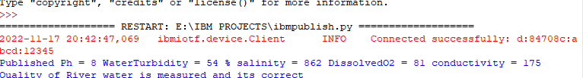
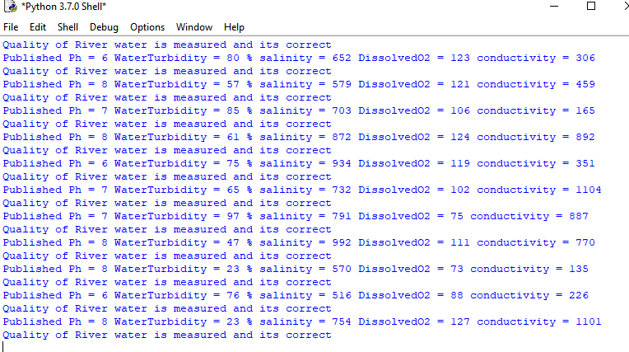
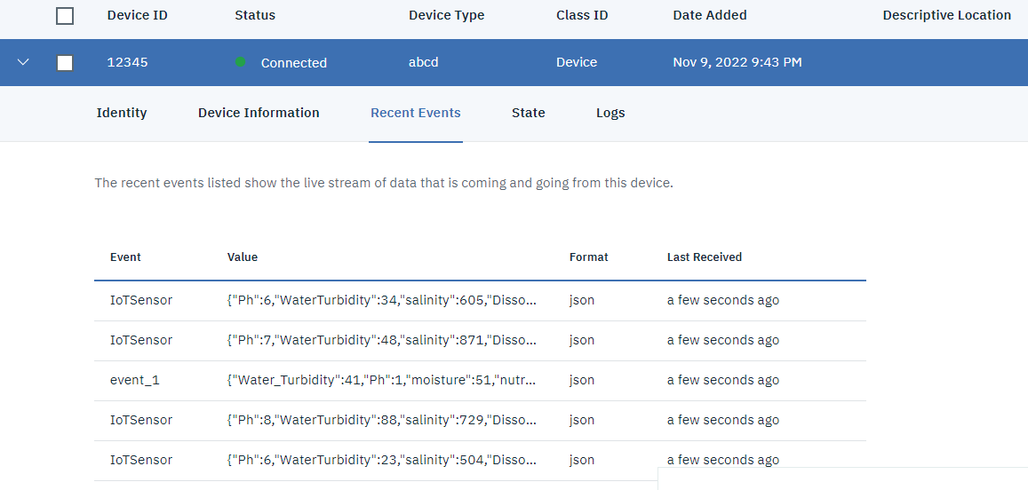

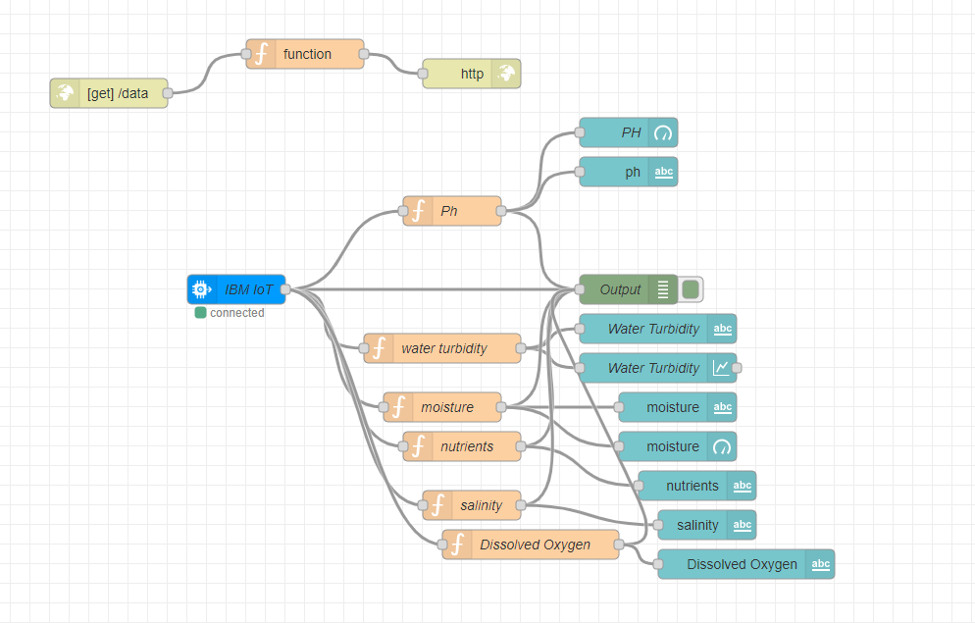

HTML CODE:
<!DOCTYPE html>
<html lang="en">
<head>
<style>
h1 {text-align: center;} p {text-align: center;} div {text-align: center;} body {
background-image: url("https://thumbs.dreamstime.com/b/clear-transparent-light-blue- water-pool-texture-background-150961732.jpg");
background-color: #cccccc;
}
</style>
<meta charset="UTF-8">
<meta http-equiv="X-UA-Compatible" content="IE=edge">
<meta name="viewport" content="width=device-width, initial-scale=1.0">
<title>Login page in HTML</title>
</head>

<body>

<h1>Login Page</h1>
<form action="">
<!-- Headings for the form -->
<div class="headingsContainer">
<h3>Sign in</h3>
<p>Sign in with your username and password</p>
</div>

<!-- Main container for all inputs -->
<div class="mainContainer">
<!-- Username -->
<label for="username">Your username</label>
<input type="text" placeholder="Enter Username" name="username" required>

<br><br>

<!-- Password -->
<label for="pswrd">Your password</label>
<input type="password" placeholder="Enter Password" name="pswrd" required>

<!-- sub container for the checkbox and forgot password link -->
<div class="subcontainer">
<label>
<input type="checkbox" checked="checked" name="remember"> Remember me
</label>
<p class="forgotpsd"> <a href="#">Forgot Password?</a></p>
</div>
<button type="submit" onclick="window.location.href = 'https://node-red-qltdp-2022-11-07.eu-gb.mybluemix.net/ui';">Login</button>

<!-- Sign up link -->
<p class="register">Not a member? <a href="#">Register here!</a></p>

</div>
</p>

</form>
</body>
</html>

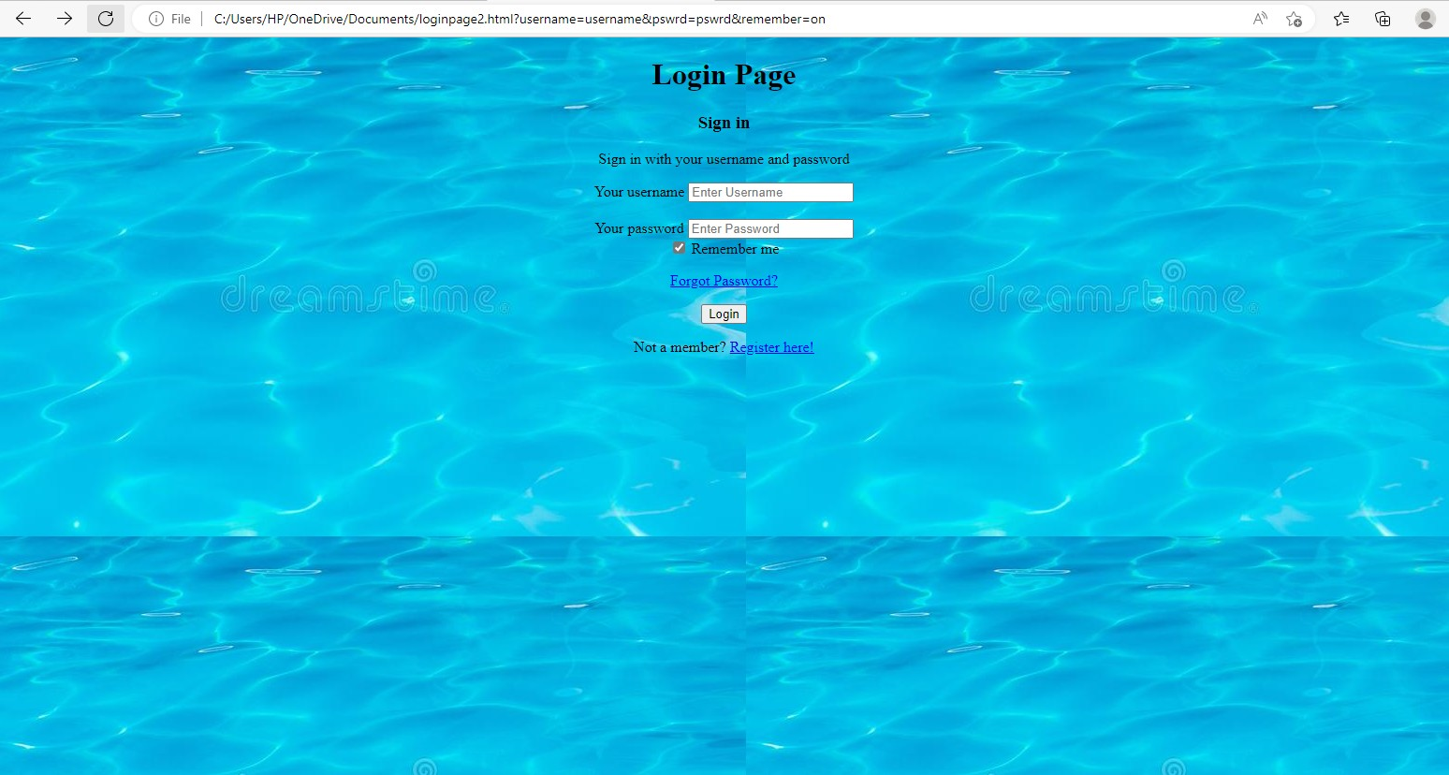

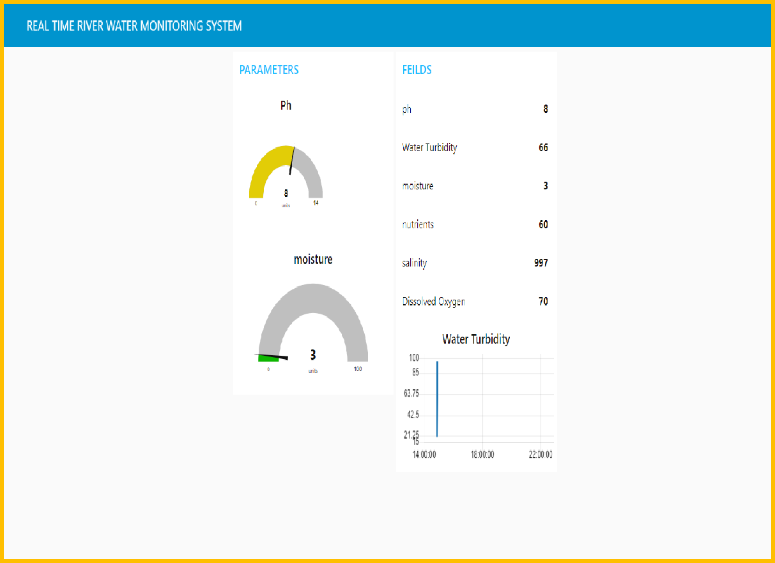

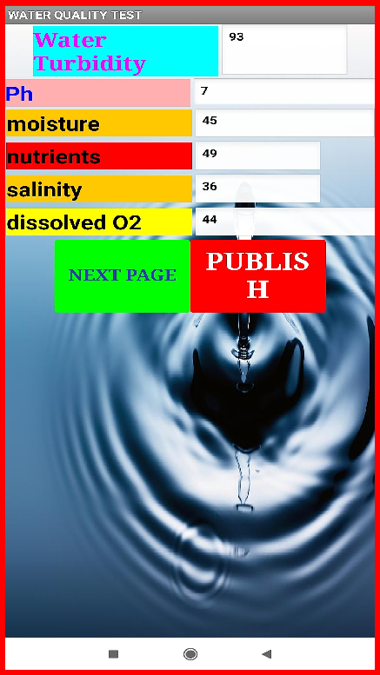
MOBILE APP

  - GIT-HUB LINK:

https://github.com/IBM-EPBL/IBM-Project-53580-1661418926

